FLEXIBILITY: 2017 and 2018 Legislative sessions enacted flexibility for use of what would otherwise be categorical funding. Accessing this flexibility is regulated, with all three requiring a school board resolution:

- HF 564 Categorical Flexibility from 2017 allowed transfer from general fund to student activity fund for protective equipment retroactive to July 1, 2016 (p. 6)

- HF 565 Flex Fund Account 2017 set up a flexibility fund to receive transfers from categorical fund balances in professional development, home school assistance, preschool and a discontinued fund. Although enacted in the 2017 Session, the ability to dedicate funds to another purpose is effective July 1, 2017 (p. 2)

- HF 2441 Flexibility 2018 allows student activity fund transfer for refurbished (in addition to new) athletic equipment and allows transfer of child care fund balance to general fund (p. 6)

This table lists the requirements for board action/resolution in the various bills passed over the last two years and copies of sample resolutions for each purpose follow on pages 2-6. Page 7 includes the form for publishing of the public hearing.

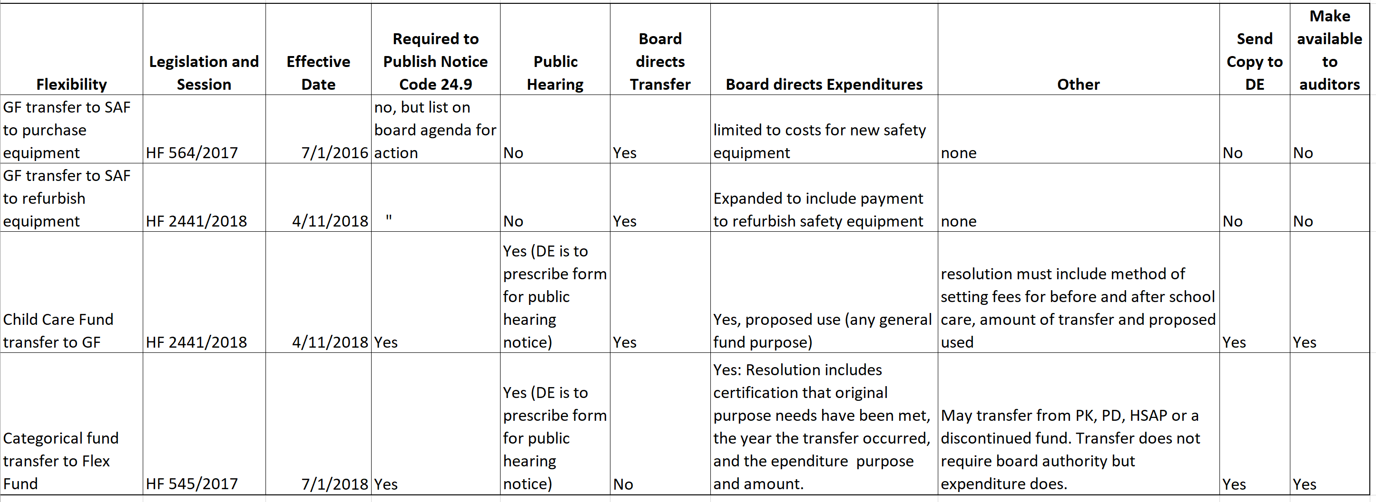

margaret@iowaschoolfinance.com (515)201-3755
January 20, 2020
A RESOLUTION DIRECTING EXPENDITURES OF THE SCHOOL FLEXIBILITY FUND
The Superintendent of the George-Little Rock Community School District presents the following Resolution for adoption:
WHEREAS, HF 565 School Flexibility Fund, was established in the 2017 Legislative Session to provide local control and flexibility regarding the use of ending balances in certain categorical funds effective July 1, 2018: and
WHEREAS, the George-Little Rock Community School Board of Directors conducted a public hearing on January 20, 2020 as required by Iowa Code 298A.2(d), using the form of public hearing prescribed by the Iowa Department of Education, which was published in the same manner as required in Iowa Code 24.9, to provide adequate notice to stakeholders and transparency of intended board action; and
WHEREAS, the George-Little Rock Community School District has fulfilled the needs intended to be met by the following categorical funds, as hereby certified by the Board of Directors, and that the statutory requirements for the following original sources of funds have been met, have been repealed, or are no longer in effect as noted below
Statewide four-year old Preschool Program under Iowa Code 256C was provided to students in the 2019 fiscal year from which the ending balance is carried forward, and preschool programming was provided to all eligible students for whom a timely application for enrollment was submitted, and a balance remains unencumbered and unobligated at the close of FY 2019
WHEREAS, the George-Little Rock Community School District has transferred the following funds authorized pursuant to HF 565 into the School Flexibility Fund
Statewide four-year old Preschool Program under Iowa Code 256C ending balance of $265,288 of which $265,000 was transferred to the Flexibility Fund from FY 2019
WHEREAS, the Board of Directors of the George-Little Rock Community School District has determined the needs of students would be better served by the flexible expenditure of these funds during the budget year beginning in or after the calendar year in which the transfer to the flexibility fund occurs, for the following purposes:
Any school district general fund purpose, specifically, instructional tools and or materials to support the curriculum, $265,000
Now, therefore be it RESOLVED, that the Board of Directors of the George-Little Rock Community School District, acknowledges the transfer of such funds to the Flexibility Fund within the General Fund, and requires expenditures accordingly for those purposes stated above, total amount of $265,000 to be available for expenditure effective for the 2020 Fiscal Year.
RESOLVED, that the Superintendent is directed to include the information concerning such expenditure in the budget certified in accordance with Iowa Code 24; and be it further
RESOLVED, that the Superintendent is directed to provide a copy of this Resolution to the Iowa Department of Education as they prescribe and make such Resolution available for any audit of the district performed under chapter 11.
Resolution approved, January 20, 2020 by the George-Little Rock Community School District board of directors:
Jason Fugitt Aye Nay
Kristi Landis Aye Nay
Austin Lloyd Aye Nay
Wade Netten Aye Nay
Andrew Sprock Aye Nay
Signed,

___________________________
President – Board of Directors
George-Little Rock Community School District

___________________________
Superintendent
George-Little Rock Community School District

Attest:
___________________________
Board Secretary
George-Little Rock Community School District

